Software Project Report

HelpMate Mobile App

**Sirisha Veeraganta**

# Abstract

This product is unique and independent by its features but there are many mobile apps in the market which work on the similar concept of interacting with user and handling the user’s task more efficiently. Most of the other products are standalone independent software while HelpMate will try to integrate these applications into one product.

HelpMate needs to communicate with other apps on the phone in order to retrieve information and utilize that to alert or notify the user. HelpMate largely utilizes the GPS on the phone to communicate and keep the track record of its locations.

Helpmate also connects to the call history and updates its internal database with number of times calls made to each number. This information is used to classify the contacts list and favorites by prompting to user to help generate a favorite list.

HelpMate is a virtual assistant for windows devices. Your very own personal assistant awaits your commands – performing tasks, notifying you about important events, and making your daily routine easier (and, often, more fun along the way).Our goal is to make working with everyday technology easier, more effective, and more fun so that you are free to enjoy the important things in life.

This product is best suitable to everyone who uses smart phone extensively. Helpmate communicates with the other apps on the mobile and sends the user updates and alerts.

Some of the important features of HelpMate:

* Parking lot assist (Park Mate)
* Stay Connected with contact favorites (Stay Connected Mate)
* GPS Tracker (GPS Mate)

Basically the software needs both Internet and GPS to fetch and display results. All system information is maintained in a database. The software also interacts with the GPS-Navigator software which is required to be an already installed application on the user’s mobile phone.

# Acknowledgements

I would like to thank Dr. Kenneth Magel for giving his valuable suggestions for the project. He helped me in shaping the project and his ideas and inputs were quite helpful in executing the task easily.

# Park Mate

This app tells us where our car is parked and navigates us to the parked car location. It lets you save the current location of the car or delete the saved location as shown in the screen shot below.

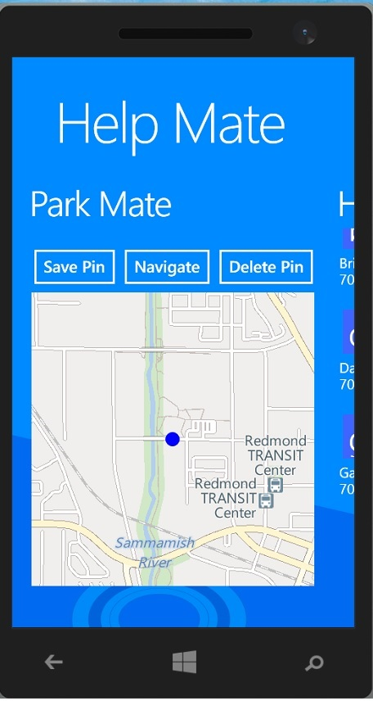

# Stay Connected Mate

This app lets us stay connected with our loved ones. It lets the user customize on how frequently a friend or relative should be called. For example you may want to keep in touch with your friends once a month. The phone detects the last time you had a conversation with a friend and signals the user if it has been a month since the friend was communicated. It lets you add a person to favorites so that it signals only for a selected few friends as compare to all the contacts on the phone. You can also edit the favorites list.

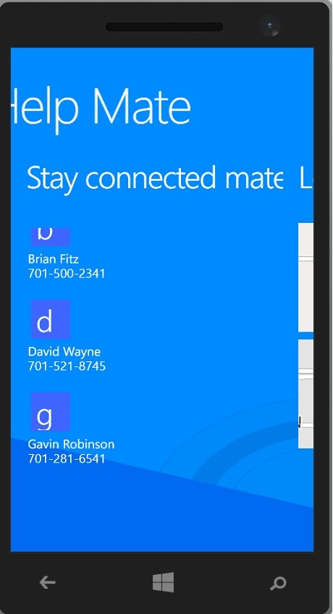

Windows phone lets the user selection screen easy via its jump list.

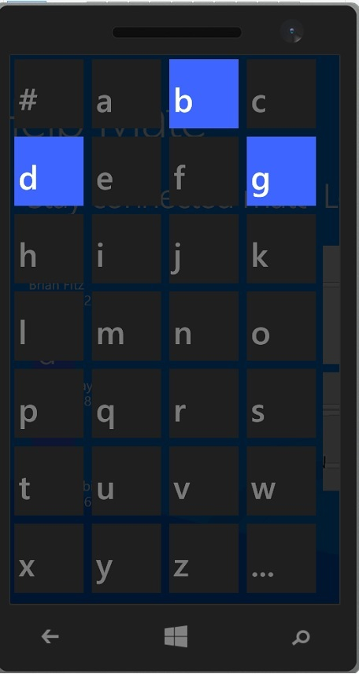

# GPS mate

GPS mate detects the frequently places a person has visited and builds a database from it. It automatically detects if a person hasn’t been to a place over a period of time. Suppose a student goes to class every day at 9AM, if there is a change of behavior over some period of time then the phone detects it and signals the user.

